Question 4
- Below
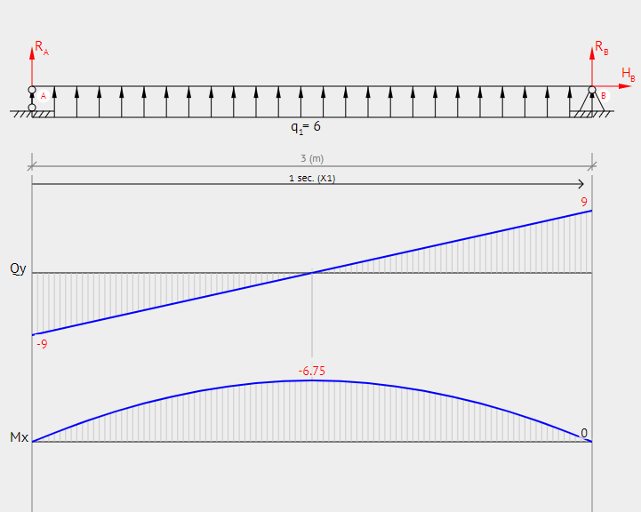
Magnitude = 42
Location
- State of stress element

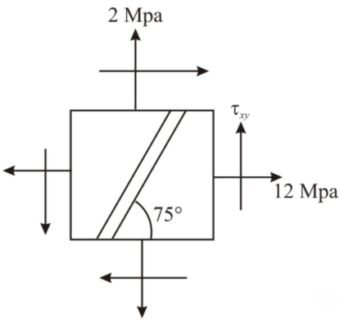
Tensile stress in x-direction σ_{x} = 12 Mpa
Tensile stress in y-direction σ_{y} = 2Mpa
In-plane shear stress parallel to the weld is T_{xy} = 0

Mohr’s Circle with the prevailing stress conditions, considering 1Mpa = 10mm on the axes
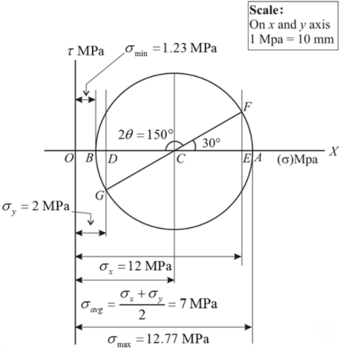
To construct Mohr’s Circle:

1) Take a point O and draw a horizontal line OX.

2) Cut OE and OD equal to the tensile stresses σ_{x} (12 Mpa – 120mm) and σ_{y} (2Mpa = 20 mm) to scale towards right and bisect DE at C.

3) Through C draw a line CF making an angle 2θ = 150 degrees with O-X line in clockwise direction as shown in the diagram.

4) With C as center and radius equal to CF, draw the Mohr’s circle of stresses.
From the Mohr’s Circle, the mean shear stress found on scale is,
Average shear stress:
σ_{average} = (σ_{x} + σ_{y}) / 2
σ_{average} = (12 Mpa + 2 Mpa) / 2
σ_{average} = OC (vector)
= 70 mm
= 7 Mpa

Given t_{xy} = 0, x id a principal direction
Θp = - 15 degrees
Looking at the picture,
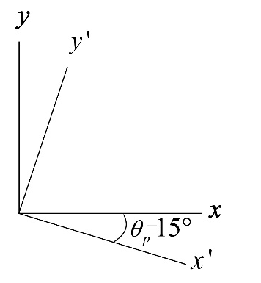

- From the Mohr’s circle,
t_{xy} = DG (vector)
t_{xy} = ((σ_{x} - σ_{y} ) / 2) tan 2Θp
= - 28.9 mm
= - 2.89 Mpa
Therefore, the shear stress for which the in-plane shear stress parallel to the weld is zero is t_{xy} = - 2.89 Mpa

From the Mohr’s circle, the maximum shear stress found on scale is,
T_{max} = BC (vector)
T_{max} = square root (((σ_{x} - σ_{y} ) / 2)^2) + t_{xy} ^2
= square root (((12 - 2) / 2)^2) + t_{xy} ^2
= 57.7 mm
= 5.77 Mpa

